Project Design Phase-II
Data Flow Diagram & User Stories

Category | Details
Date | 25 June 2026
Project Name | EduGenie: AI-Powered Learning Assistant

Data Flow Diagram (Level-0)
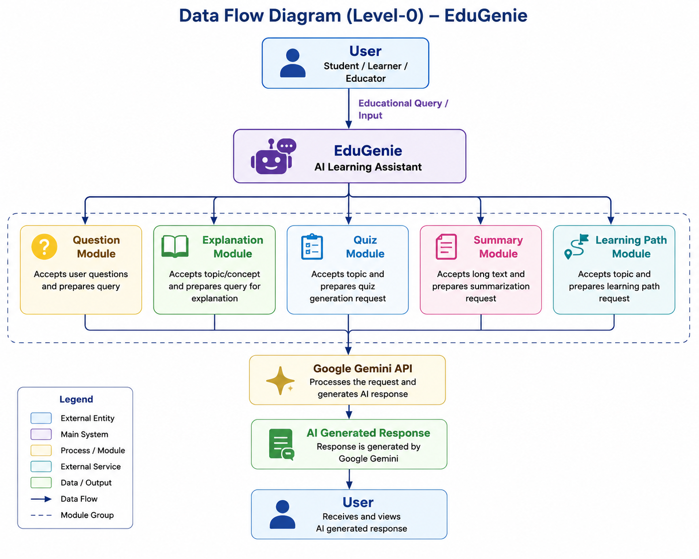

User Stories

User Type | Requirement | No. | User Story | Acceptance Criteria | Pri. | Rel.
Student | Question Answering | USN-1 | Ask educational questions for instant answers. | Accurate AI answers generated. | High | S-1
Student | Concept Explanation | USN-2 | Simplified language for difficult concepts. | Simple explanation displayed. | High | S-1
Student | Quiz Generation | USN-3 | Test understanding with AI quizzes. | MCQs generated successfully. | High | S-1
Student | Summarization | USN-4 | Summarize long text for revision. | Summary retains key points. | High | S-1
Student | Learning Path | USN-5 | Personalized roadmap for topics. | Level-based path generated. | High | S-2
Student | Responsive UI | USN-6 | Easy interface for all tools. | All features on one page. | Med | S-2
Educator | Assistance | USN-7 | Quick content generation help. | Accurate/relevant responses. | Med | S-2
Self-Learner | Integrated Platform | USN-8 | All features in one application. | Access all modules in one app. | Med | S-2

